An Internship Report
Of
C++ Programming

Submitted
To
School of Computer Science and Engineering
IILM University, Greater Noida, U.P.

In partial fulfilment of the requirement of degree of
B-Tech (CSE)



By

Roll Number of Student:- 25SCS1003001673
Name of Student: SOHAM NANDA

Batch: 2026-27

CANDIDATE'S DECLARATION
I, SOHAM NANDA, do hereby declare that the internship report titled “C++ Programming” has been completed by me to fulfil the requirement for the award of the degree of Bachelor of Technology in Computer Science and Engineering. All the references have been quoted and I have not taken as such any material from any other source. I affirm that this report is my own and has not been submitted to any other institute for any degree/diploma requirement, and further I shall be solely responsible for any kind of copyright violation in this regard.
Signature:-

Student Name: SOHAM NANDA

Roll No.: 25SCS1003001673

ACKNOWLEDGEMENT
I am using this opportunity to express my gratitude to everyone who supported me throughout the Internship Program. I am thankful for their aspiring guidance, invaluably constructive criticism and friendly advice during this work. I am sincerely grateful to them for sharing their truthful and illuminating views on a number of issues related to this work.
I would like to thank the C++ Programming Internship team and the internship learning program for providing me the opportunity and the structured platform to learn and gain hands-on exposure in the domain of C++ Programming. I am also thankful to my institute, IILM University, Greater Noida, and the faculty of the School of Computer Science and Engineering for their continuous support and encouragement.
I express my gratitude to my parents for their blessings.
Signature:

Student Name: SOHAM NANDA

Roll No.: 25SCS1003001673

TABLE OF CONTENTS
1. Candidate's Declaration i
2. Acknowledgement ii

4. Project Description 1
4.1 Introduction 1
4.2 Internship Overview 2
4.3 Problem Statement 3
4.4 Project Objectives 3
4.5 Scope of the Project 4
4.6 Technologies and Tools Used 4
4.7 System Architecture 5
4.8 Methodology 6
4.9 Expected Outcomes 7

5. Bibliography/References 9

4. PROJECT DESCRIPTION

4.1 Introduction
This report summarizes a C++ Programming Internship focused on strengthening programming fundamentals and applying them through practical exercises. The report covers the concepts studied, the development workflow, problem-solving methods, and the learning outcomes relevant to the Bachelor of Technology in Computer Science and Engineering programme at IILM University, Greater Noida.
The learning process was organized around core C++ concepts, short coding exercises, debugging practice, and a small console-based project. The work emphasized writing readable code, compiling and testing programs, and understanding how fundamental programming concepts are used to solve computational problems.

4.2 Internship Overview
This report is prepared as an academic account of C++ programming learning and practice. It does not claim affiliation with a specific external organization or the issuance of an internship certificate.

4.3 Problem Statement
Students may understand programming concepts theoretically but need regular practice to translate them into working programs. Common challenges include selecting suitable data types, designing logical steps, using functions and classes correctly, handling input and output, and finding errors during compilation or execution. This internship focuses on building these practical C++ programming skills through structured exercises and a small application.
4.4 Project Objectives
- To understand the C++ program development cycle, from writing source code to compiling, testing, and debugging.
- To learn advanced API deployment of AI models using C++, including asynchronous operations.
- To gain hands-on experience with compiler and development environment containerization and CI/CD pipelines for ML workflows.
- To deploy AI/advanced C++ programming models on development environments such as Amazon SageMaker, Google Vertex AI, and Azure C++ programming.
- To build modular C++ applications using functions, classes, and standard library components.
- To integrate AI models into web and mobile applications using console-based interfaces, while ensuring security, privacy, and bias mitigation.
- To learn basic debugging techniques and test programs with different inputs.
- To improve program efficiency and use selected Standard Template Library components where appropriate.
- To apply all the above concepts in a real-world, end-to-end practice project.

4.5 Scope of the Project
The scope includes C++ syntax, variables and data types, operators, conditional statements, loops, arrays, strings, functions, pointers and references, object-oriented programming, file handling, and basic use of the Standard Template Library. Practice is carried out in a local development environment using a C++ compiler. The report describes learning activities and sample implementation work rather than claiming deployment in a live organization.
4.6 Technologies and Tools Used
- Programming Language: C++
- Development Tools: Visual Studio Code or another C++ IDE
- Compiler: GCC (g++) or an IDE-integrated C++ compiler
- advanced C++ programming & Agent Frameworks: LangChain, LlamaIndex, LangGraph, vLLM
- Application Type: Console-based programs
- Testing: Sample test cases, output checking, and debugging
- CI/CD & software development: CI/CD pipelines for machine learning workflows
- Standard Library: Common headers and selected STL containers
4.7 Program Development Workflow
The program development workflow followed during the internship can be summarized in the following stages:
- Problem Analysis: Understand the task and identify inputs, outputs, and constraints.
- Algorithm Design: Write a step-by-step solution before coding.
- Implementation: Convert the algorithm into a C++ source program.
- Compilation: Compile the source code and resolve syntax or type errors.
- Execution: Run the program with representative input values.
- Testing: Check expected outputs, edge cases, and invalid input where relevant.
- Improvement: Refactor code for readability and reuse.
4.8 Methodology
The learning process was organized around core C++ concepts, short coding exercises, debugging practice, and a small console-based project. The work emphasized writing readable code, compiling and testing programs, and understanding how fundamental programming concepts are used to solve computational problems.
1 | C++ Fundamentals | Compiler setup, program structure, variables, data types, operators, and input/output.
2 | Control Flow | Conditional statements, switch, loops, and nested control structures.
3 | Arrays and Strings | Traversing arrays, common string operations, and basic searching.
4 | Functions | Function declarations, parameters, return values, scope, and function overloading.
5 | Pointers and References | Address and dereference operators, references, and safe basic usage.
6 | Object-Oriented Programming | Classes, objects, constructors, encapsulation, and inheritance.
7 | Files and Standard Library | Basic file input/output and selected Standard Template Library components.
8 | Practice Project and Review | Design, implementation, testing, debugging, and final review of a console-based application.
8 | Applied AI Projects & Capstone Projects | Real-world case studies (e-commerce & healthcare), full-stack RAG application development (FastAPI backend + frontend), AI agent for business automation, and complete end-to-end production AI solution including model development, API deployment, monitoring, and scaling.

Practice exercises and a final review were used to check understanding of the concepts and improve the quality of the code.

4.9 Expected Outcomes
- Ability to write, compile, test, and debug basic C++ programs.
- Practical understanding of conditions, loops, arrays, strings, and functions.
- Hands-on practice with classes, objects, constructors, and basic object-oriented design.
- Capability to design and build modular C++ applications for business use cases.
- Understanding of input validation, readable code, and basic error prevention.
- Improved ability to test program outputs and trace common logical and compilation errors.
- A small console-based C++ project demonstrating input/output, control flow, functions, and object-oriented concepts.

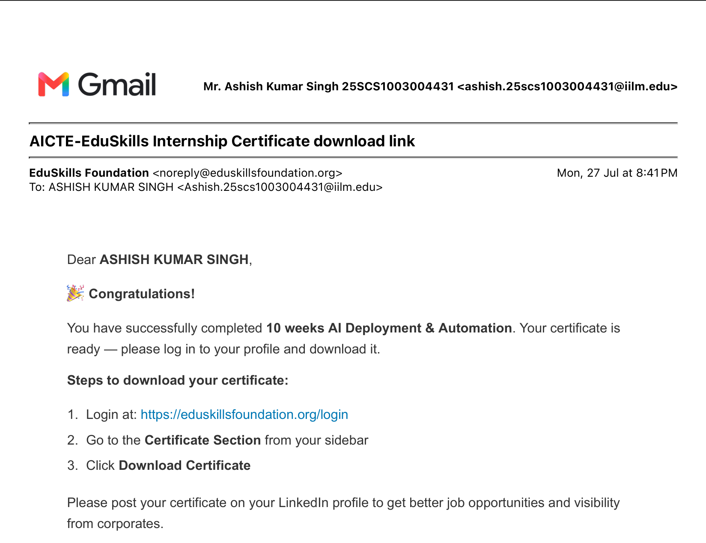
5. BIBLIOGRAPHY/REFERENCES

2. cppreference.com, C++ language reference, https://en.cppreference.com/
3. C++ Documentation, https://fastapi.tiangolo.com/
4. compiler and development environment Documentation, https://docs.docker.com/
5. modular program design Documentation, https://kubernetes.io/docs/

